# Staff Report

Meeting Date: October 17, 2023

To: Siskiyou County Board of Supervisors

From: Hailey Lang, Planning Director

Subject: Proposed Zone Change (Z-23-03) to rezone APNs 020-470-400 and 020-470-360 from Neighborhood Commercial (C-U) to Heavy Industrial (M-H) and APN 020-470-420 from Rural Residential (R-R) to Heavy Industrial (M-H)

## Background

Jeremy Ward applied for a zone change to Heavy Industrial (M-H) in order to bring the current residential and commercial zoning districts into conformance with the historic industrial use of the property. The project site is east of U.S. Route 97, approximately one mile north of Weed and adjacent to 1st Street and State Highway 97. Surrounding properties are privately owned and include a mix of commercial, residential and agriculture properties.

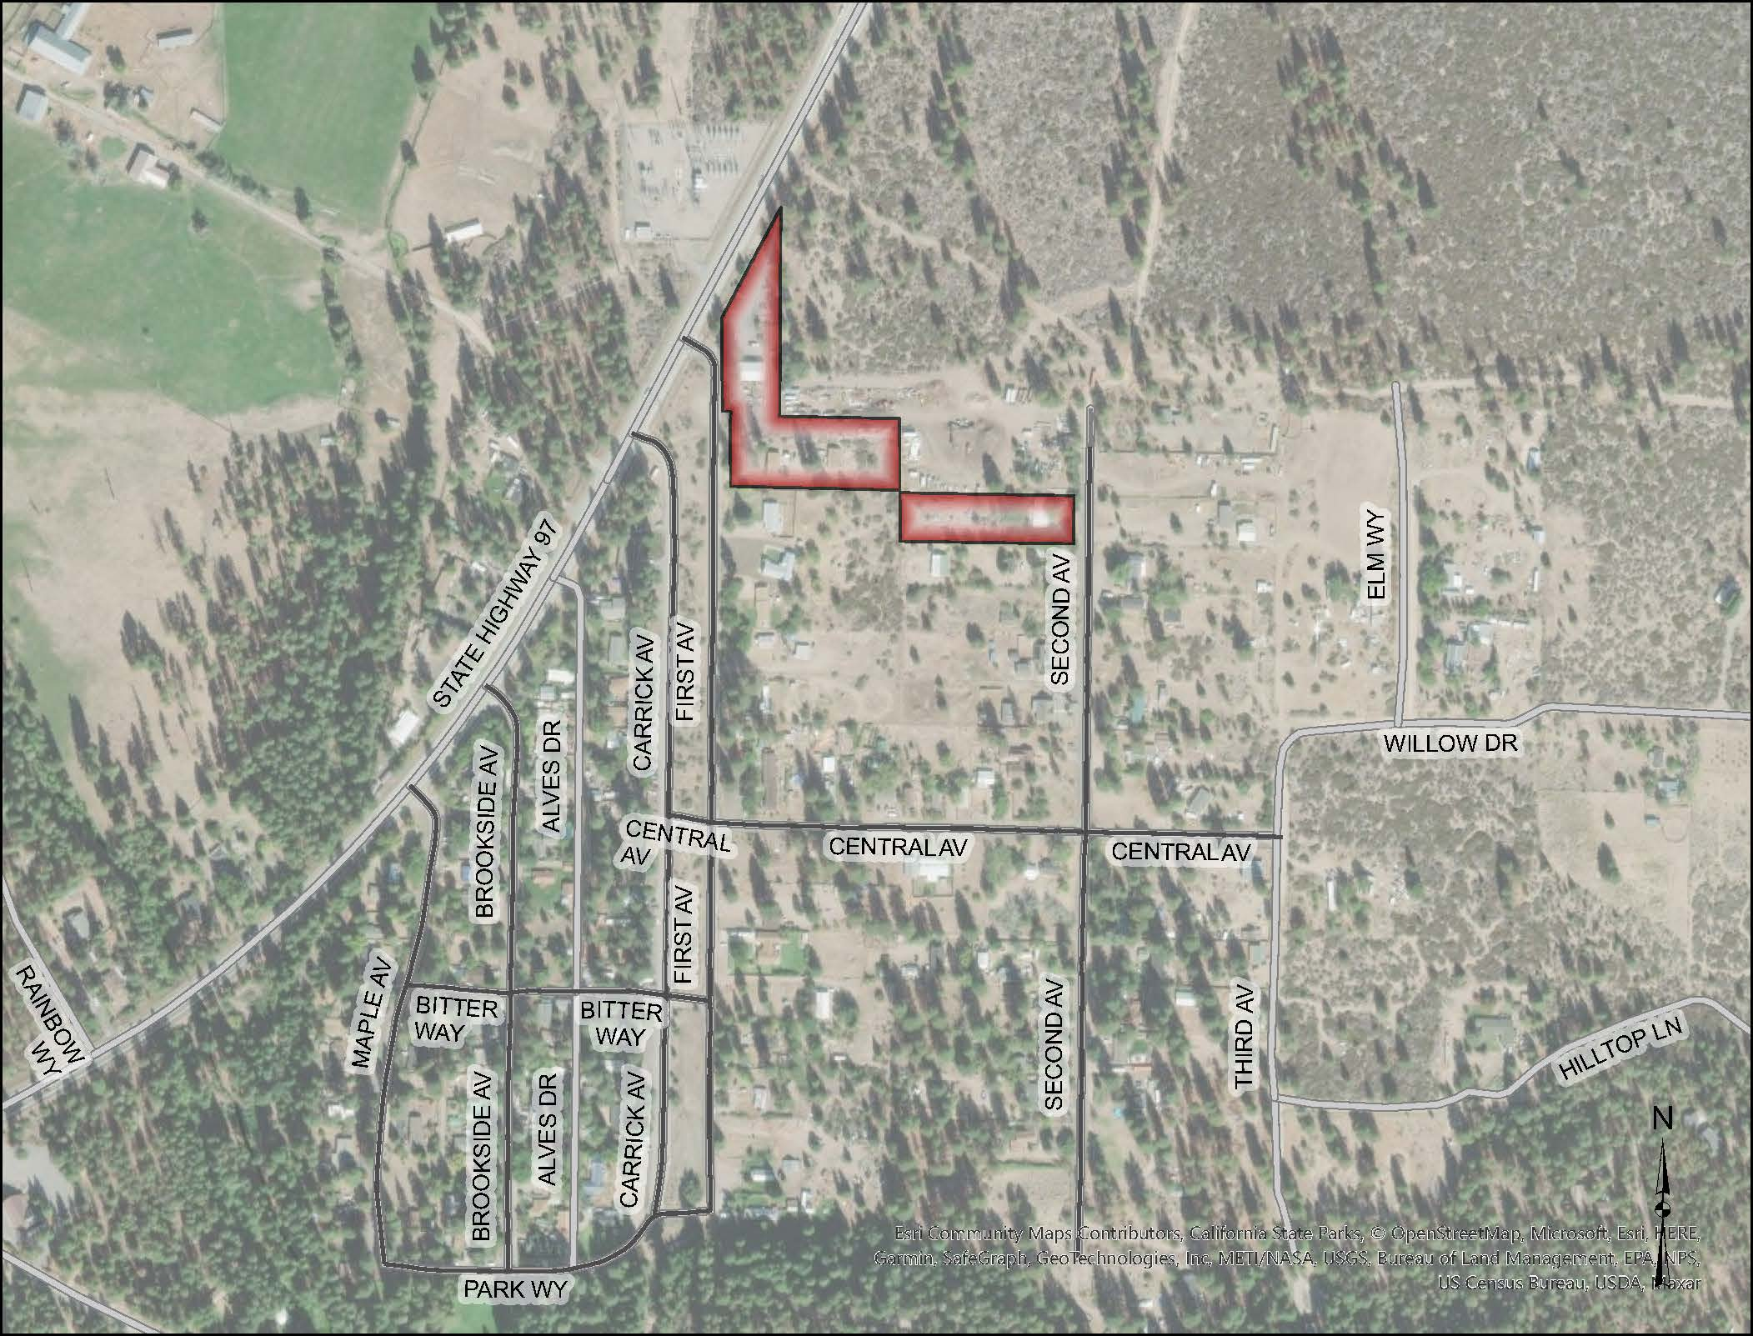

**Figure 1: Location Map**

APNs 020-470-400, 020-470-360 and 020-470-420 are currently used for the storage of trucks, bulk storage, and storage of projects which require heavy machinery. The project site is also used for bulk storage and repair of gasoline station equipment.

## Environmental Review

The project site is already developed with Heavy Industrial (M-H) uses and the zone change is proposed to apply the district that best fits with the historic use of the project site. No new development is proposed.

Staff evaluated the project’s potential for environmental impacts by reviewing the project relative to Appendix G of the CEQA Guidelines. Based on this review, it was determined that the rezone, as proposed, would not adversely impact the environment.

Because there is not substantial evidence, in light of the whole record before the County, that the proposed zone change may have a significant effect on the environment, staff is recommending that the Planning Commission and Board of Supervisors make the finding that the project is exempt from the California Environmental Quality Act (CEQA) pursuant to the “common sense exemption” of CEQA Guidelines Section 15061(b)(3), which states that “CEQA applies only to projects which have the potential for causing a significant effect on the environment. Where is can be seen with certainty that there is no possibility that the activity in question may have a significant effect on the environment, the activity is not subject to CEQA.” Additionally, staff is recommending this project be determined exempt pursuant to the Class 1 exemption that is applicable to Existing Facilities (Section 15301).

The Class 1 section consists of the operation, repair, maintenance, permitting, leasing, licensing, or minor alteration of existing public or private structures where there is negligible or no expansion of existing or former use. The property has been developed for uses appropriate to the M-H district starting since 1936. No expansion of the existing structures or uses is proposed and no new structures or uses are proposed.

The proposed CEQA exemptions must be considered together with any comments received during the public review process. Further, the exemptions can only be approved if the finding is made, based on the whole record before it, that there is not substantial evidence that there are unusual circumstances (including future activities) which might reasonably result in the project having a significant effect on the environment.

## Comments

One public comment was received after the Planning Commission meeting. The comment letter opposes the zone change due to the current operation creating dust and noise.

## Recommended Action

As detailed in Resolution PC 2023-013, it is the recommendation of the Planning Commission that the Board of Supervisors Determine the Project Exempt from the California Environmental Quality Act and Approve the Ward Zone Change (Z-22-03) by Adopting a Draft Ordinance Rezoning approximately 2.1-acres (APNs 020-470-360, APN 020-470-400 and 020-470-420 from C-U and R-R-B-1 to M-H.

Should the Board of Supervisors concur with the recommendation of the Planning Commission, the Board of Supervisors must adopt an ordinance amending Zoning District Map 10-6.205-412. A draft motion to this effect is provided below.

## Recommended Motions

I move to take the following actions:

1. Introduce, waive, and approve the first reading of the proposed Ward rezoning to amend Zoning District Map 10-6.205-412; and
2. Direct the Clerk to schedule a continued public hearing on adoption of the CEQA exemption and a second reading of the ordinance amending Zoning District Map 10-6.205-412.

## Attachments

1. Draft Ordinance No. _______, an Ordinance of the County of Siskiyou, State of California, Reclassifying Land Northeast of the City of Weed from Neighborhood Commercial (C-U) and Rural Residential (R-R) to Heavy Industrial (M-H) on APNs: 020-470-360, 020-470-400, and 020-470-420; Township 42 North, Range 4 West, Section 31, MDB&M
2. Exhibit A: Zoning Ordinance Map
3. Planning Commission Staff Report – September 20, 2023
4. Signed Resolution PC 2023-013
5. Comment Letter dated September 13, 2023